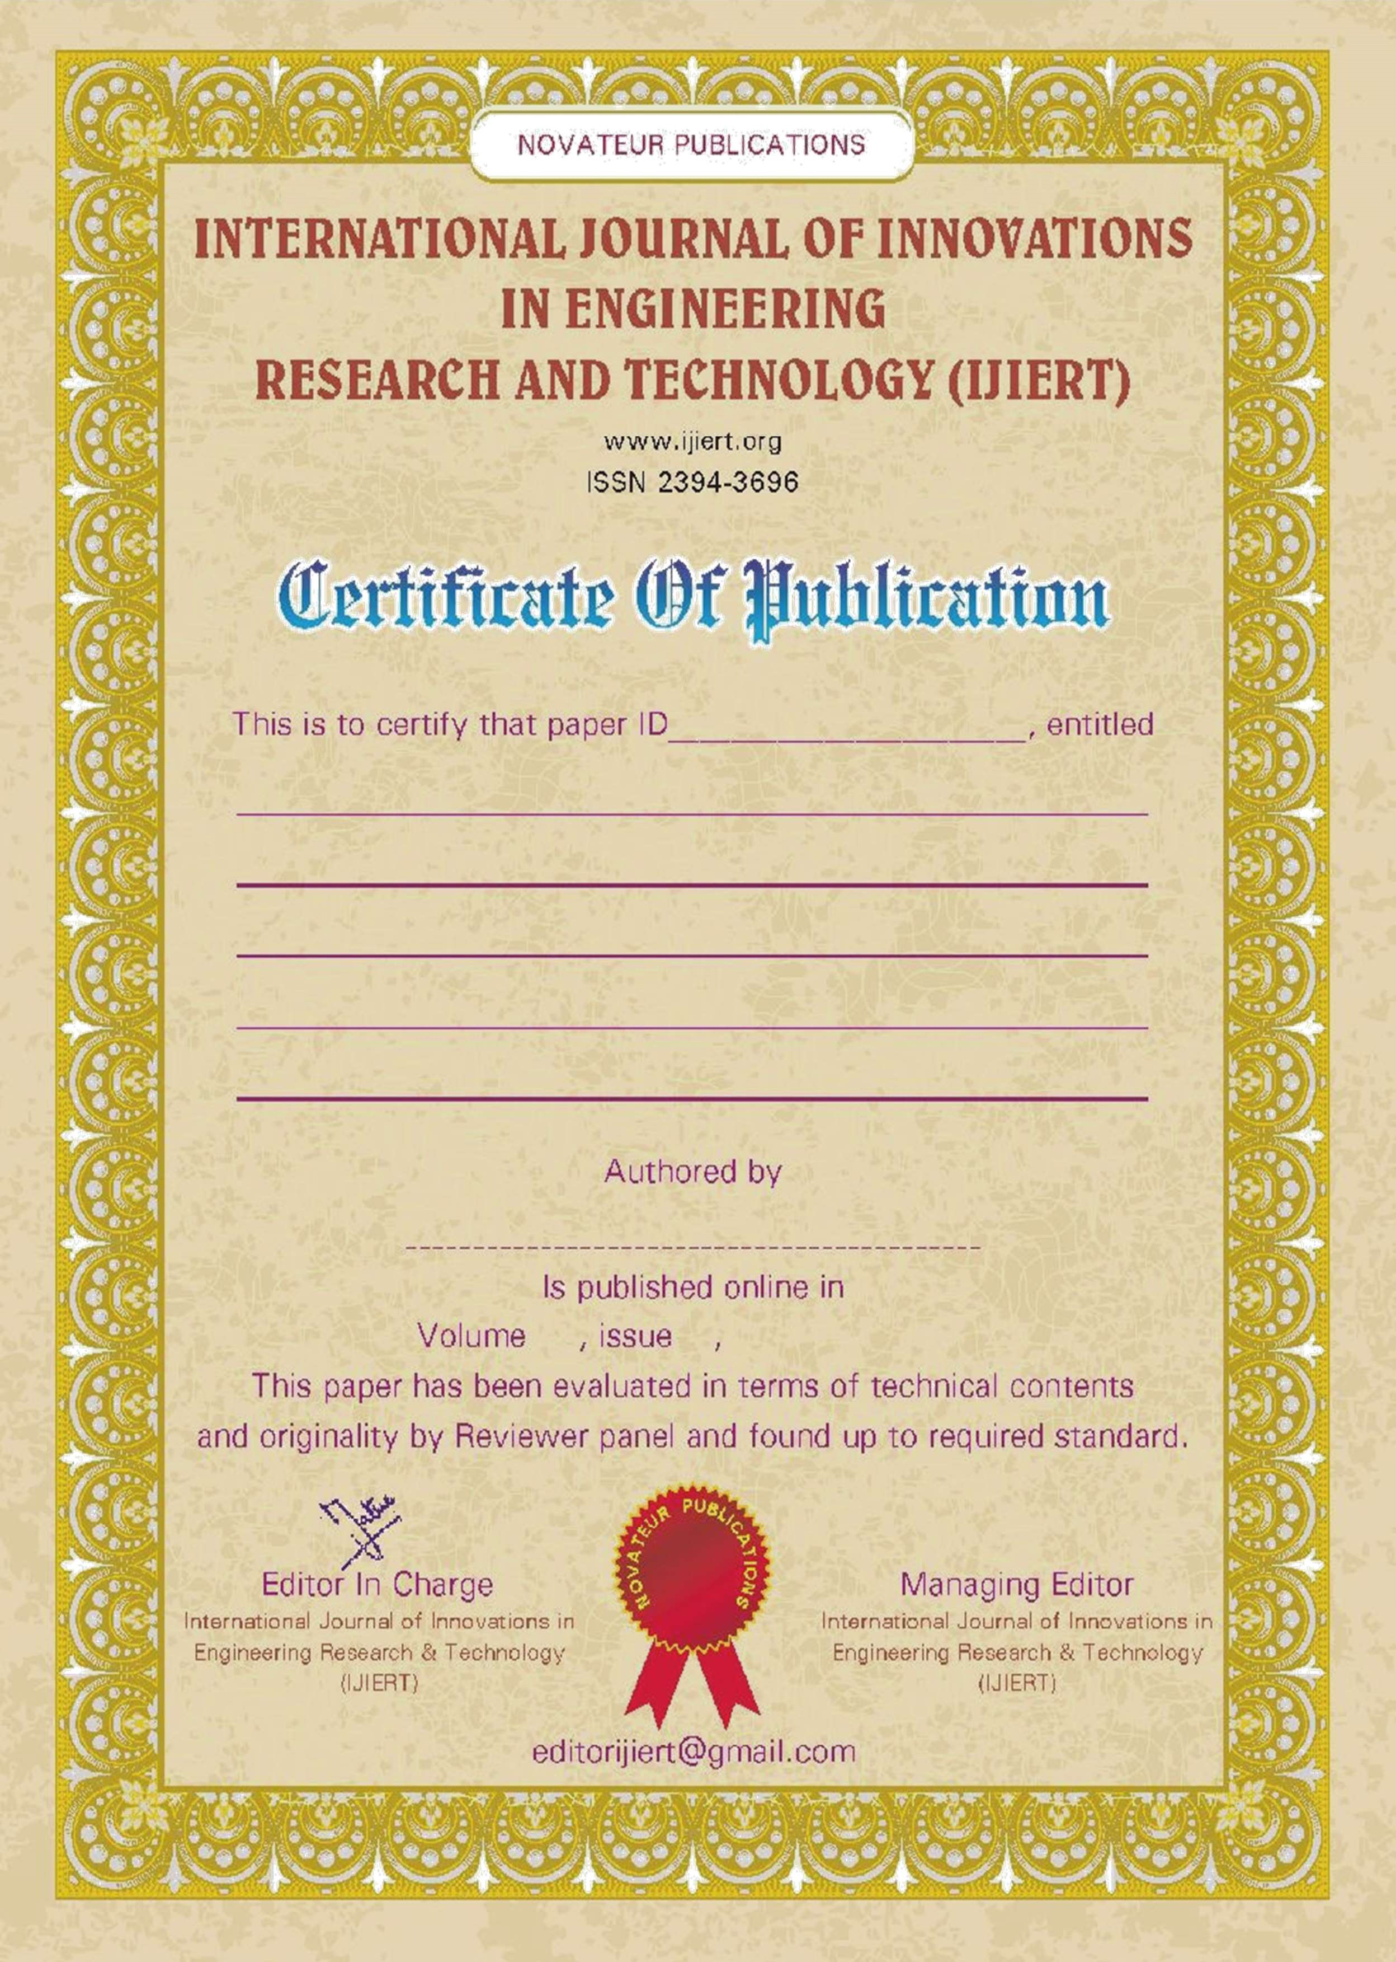

NOVATEUR PUBLICATION

## International Journal of Innovations In Engineering

**Research and Technology**

**{IJIERT}**

**Let’s Innovate**

ISSN 2394-3696

Impact factor 5.558 (2020-21)

# CERTIFICATE OF PUBLICATION

This is to certify that paper ID 1589179587, entitled

**OVERVIEW OF FIXTURE DESIGN FOR INDIAN INDUSTRIES**

**Authored by**

PATIL BHASKAR SAMBHAJI

**Is Published Online in Volume-7, Issue-5, May - 2020**

This Paper Has Been Evaluated In Terms Of Technical Contents and Originality By Reviewer Panel and Found Up To Required Standard.

**Managing Editor** International Journal of Innovations in Engineering Research and Technology

{IJIERT}

[www.ijiert.org](http://www.ijiert.org/)

[**editorijiert@gmail.com**](mailto:editorijiert@gmail.com)



NOVATEUR PUBLICATION

**International Journal of Innovations In Engineering**

**Research and Technology**

**{IJIERT}**

**Let’s Innovate**

ISSN 2394-3696

Impact factor 5.558 (2020-21)

# CERTIFICATE OF PUBLICATION

This is to certify that paper ID 1589179587, entitled

**OVERVIEW OF FIXTURE DESIGN FOR INDIAN INDUSTRIES**

**Authored by**

MHATRE SAIRAJ SUDHAKAR

**Is Published Online in Volume-7, Issue-5, May - 2020**

This Paper Has Been Evaluated In Terms Of Technical Contents and Originality By Reviewer Panel and Found Up To Required Standard.

**Managing Editor** International Journal of Innovations in Engineering Research and Technology

{IJIERT}

[www.ijiert.org](http://www.ijiert.org/)

[**editorijiert@gmail.com**](mailto:editorijiert@gmail.com)



NOVATEUR PUBLICATION

**International Journal of Innovations In Engineering**

**Research and Technology**

**{IJIERT}**

**Let’s Innovate**

ISSN 2394-3696

Impact factor 5.558 (2020-21)

# CERTIFICATE OF PUBLICATION

This is to certify that paper ID 1589179587, entitled

**OVERVIEW OF FIXTURE DESIGN FOR INDIAN INDUSTRIES**

**Authored by**

GAIKAR ROHIT BHAUSAHE

**Is Published Online in Volume-7, Issue-5, May - 2020**

This Paper Has Been Evaluated In Terms Of Technical Contents and Originality By Reviewer Panel and Found Up To Required Standard.

**Managing Editor** International Journal of Innovations in Engineering Research and Technology

{IJIERT}

[www.ijiert.org](http://www.ijiert.org/)

[**editorijiert@gmail.com**](mailto:editorijiert@gmail.com)



NOVATEUR PUBLICATION

**International Journal of Innovations In Engineering**

**Research and Technology**

**{IJIERT}**

**Let’s Innovate**

ISSN 2394-3696

Impact factor 5.558 (2020-21)

# CERTIFICATE OF PUBLICATION

This is to certify that paper ID 1589179587, entitled

**OVERVIEW OF FIXTURE DESIGN FOR INDIAN INDUSTRIES**

**Authored by**

CHAUDHARI AAKASH DIGAMBER

**Is Published Online in Volume-7, Issue-5, May - 2020**

This Paper Has Been Evaluated In Terms Of Technical Contents and Originality By Reviewer Panel and Found Up To Required Standard.

**Managing Editor** International Journal of Innovations in Engineering Research and Technology

{IJIERT}

[www.ijiert.org](http://www.ijiert.org/)

[**editorijiert@gmail.com**](mailto:editorijiert@gmail.com)



NOVATEUR PUBLICATION

**International Journal of Innovations In Engineering**

**Research and Technology**

**{IJIERT}**

**Let’s Innovate**

ISSN 2394-3696

Impact factor 5.558 (2020-21)

# CERTIFICATE OF PUBLICATION

This is to certify that paper ID 1589179587, entitled

**OVERVIEW OF FIXTURE DESIGN FOR INDIAN INDUSTRIES**

**Authored by**

PROF. S. S. CHIKSHE

**Is Published Online in Volume-7, Issue-5, May - 2020**

This Paper Has Been Evaluated In Terms Of Technical Contents and Originality By Reviewer Panel and Found Up To Required Standard.

**Managing Editor** International Journal of Innovations in Engineering Research and Technology

{IJIERT}

[www.ijiert.org](http://www.ijiert.org/)

[**editorijiert@gmail.com**](mailto:editorijiert@gmail.com)